## COURSE 6 - SHARE DATA THROUGH THE ART OF VISUALIZATION

## MODULE 1

In this module, you’ll delve into the various types of data visualizations and explore what makes an effective visualization. You'll also learn about accessibility, design thinking, and other factors that will help you use data visualizations to effectively communicate data insights.

### Learning Objectives

* Explain the key concepts involved in design thinking as they relate to data visualization
* Describe the use of data visualizations to talk about data and the results of data analysis
* Discuss accessibility issues associated with data visualization
* Explain the importance of data visualization to data analysts
* Describe the key concepts involved in data visualization

## COMMUNICATE DATA INSIGHTS

### [INTRODUCTION TO COMMUNICATING DATA INSIGHTS](https://www.coursera.org/learn/visualize-data/lecture/9bc24/introduction-to-communicating-data-insights)

### [COURSE 6 OVERVIEW: SET YOUR EXPECTATIONS](https://www.coursera.org/learn/visualize-data/supplement/4Qpsh/course-6-overview-set-your-expectations)

Welcome to the sixth course in the Google Data Analytics Certificate! In this course, you’ll learn how to create data visualizations. Visualizations, along with compelling data storytelling, will help you communicate the meaning of a dataset to your audience. Sharing the results of an analysis is one of the most important parts of an analyst’s job.

This course starts with the basics: learning principles and best practices for data visualization in spreadsheets. You’ll get hands-on experience creating data visualizations in Tableau, a specialized data visualization tool. Beyond the basics, there’s a focus on professional tips for creating exciting visualizations, presentations, and talking points about your data. This course also covers how to prepare and deliver effective presentations, so you can confidently handle the most challenging questions about your data analysis. Once you’ve completed this course, you’ll be on your way to becoming a talented data storyteller!

## **Certificate program progress**

The Google Data Analytics Certificate program has eight courses. Share data through the art of visualization is the sixth course.

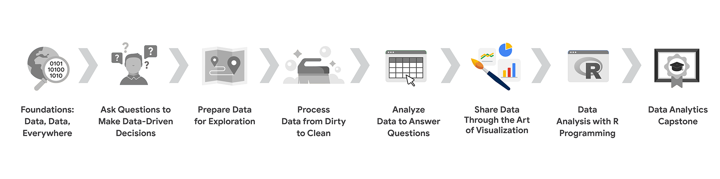

1. [Foundations: Data, Data, Everywhere](https://www.coursera.org/learn/foundations-data/home/welcome)
2. [Ask Questions to Make Data-Driven Decisions](https://www.coursera.org/learn/ask-questions-make-decisions/home/welcome)
3. [Prepare Data for Exploration](https://www.coursera.org/learn/data-preparation/home/welcome)
4. [Process Data from Dirty to Clean](https://www.coursera.org/learn/process-data/home/welcome)
5. [Analyze Data to Answer Questions](https://www.coursera.org/learn/analyze-data/home/welcome)
6. **Share Data Through the Art of Visualization** (this course)
7. [Data Analysis with R Programming](https://coursera.org/learn/data-analysis-r/home/welcome)
8. [Google Data Analytics Capstone: Complete a Case Study](https://coursera.org/learn/google-data-analytics-capstone/home/welcome)

## **Course 6 content**

This course is broken into four modules. Here’s an overview of the skills you’ll gain in each module:

### **Module 1: Visualize data**

In this module, you’ll delve into the various types of data visualizations and explore what makes an effective visualization. You'll also learn about accessibility, design thinking, and other factors that will help you use data visualizations to effectively communicate data insights.

### **Module 2: Create data visualizations with Tableau**

Tableau is a business intelligence and analytics platform that helps people visualize, understand, and make decisions with data. In this part of the course, you’ll become well-versed in Tableau’s dynamic capabilities and learn to inject creativity and clarity into your visualizations, ensuring that your findings are easy to understand.

### **Module 3: Craft data stories**

Connecting your objective with your data through insights is essential to data storytelling. In this part of the course, you’ll get acquainted with the principles of data-driven storytelling and learn to craft compelling narratives using Tableau's dashboard and filtering capabilities, giving life to your data insights.

### **Module 4: Develop presentations and slideshows**

In this part of the course, you’ll discover how to give an effective presentation about your data analysis. This final module teaches you to construct insightful presentations that resonate with your audience. You'll learn to anticipate and address potential questions and to articulate the limitations of your data, ensuring a robust and credible narrative for your stakeholders.

## **What to expect**

Each course offers many types of learning opportunities:

* **Videos** for instructors to teach new concepts and demonstrate the use of tools
* **In-video questions** that pop up from time to time to help you to check your understanding of key concepts and skills
* **Step-by-step guides** you can use to follow along with instructors as they demonstrate tools
* **Readings** to explore topics more in-depth and build on the concepts from the videos
* **Discussion forums** to share, explore, and reinforce lesson topics
* **Discussion prompts** to promote thinking and engagement in the discussion forums
* **Practice quizzes** to prepare you for graded quizzes
* **Graded quizzes** to measure your progress and give you valuable feedback

This program was designed to let you work at your own pace—your personalized deadlines are just a guide. There is no penalty for late assignments. To earn your certificate, you simply need to complete all of the work.

If you miss two assessment deadlines in a row, or if you miss an assessment deadline by two weeks, you'll see a **Reset deadlines** option on the **Grades** page. Click it to switch to a new course schedule with updated deadlines. You can use this option as many times as you need—it won’t remove any progress you’ve already made in the course, but you may find new course content if the instructor updated the course after you started. If you cancel a subscription and then reactivate it, your deadlines will automatically reset.

In this course, you'll be assessed with quizzes that are based on the wide variety of learning materials and activities that reinforce the important skills you’ll develop. Both types of quizzes can be taken more than once.

## **Tips for success**

* It is strongly recommended that you go through the items in each lesson in the order they appear because new information and concepts build on previous knowledge.
* Participate in all learning opportunities to gain as much knowledge and experience as possible.
* If something is confusing, don’t hesitate to replay a video, review a reading, or repeat a self-review activity.
* Use the additional resources that are referenced in this course. They are designed to support your learning. You can find all of these resources in the [**Resources**](https://www.coursera.org/learn/visualize-data/resources/HIQ29)tab.
* When you encounter useful links in this course, bookmark them so you can refer to the information later for study or review.
* Understand and follow the [**Coursera Code of Conduct**](https://www.coursera.support/s/article/208280036-Coursera-Code-of-Conduct?) to ensure that the learning community remains a welcoming, friendly, and supportive place for all members.

**Updates to the course**

As you complete this course, you may notice updates to the content, like new practice materials and additional examples. These updates ensure the program provides up-to-date skills and guidance that will help you in your data analytics career. If you previously completed a graded activity, you *may* need to repeat the assessment in order to complete this course. For more information, check out [the course discussion forum.](https://www.coursera.org/learn/visualize-data/discussions)

### 

UNDERSTAND DATA VISUALIZATION

[WHY DATA VISUALIZATION MATTERS](https://www.coursera.org/learn/visualize-data/lecture/SBc9P/why-data-visualization-matters)

**Your audience should know exactly what they're looking at within the first five seconds of seeing it.** Basically, this means the visual should be clear and easy to follow. In the five seconds after that, your audience should understand the conclusion your visualization is making. Even if they aren't totally familiar with the research you've been doing. They might not agree with your conclusion, and that's okay. You can always use their feedback to adjust your visualization and go back to the data to do further analysis.

So now let's talk about what we have to do to create a visualization that's understandable, effective and, most importantly, convincing. Let's start from the beginning. **Data visualizations are a helpful tool for fitting a lot of information into a small space**.

To do this, **you first need to structure and organize your thoughts**. Think about your objectives and the conclusions you've reached after sorting through data.

**Then think about the patterns you've noticed in the data, the things that surprised you and, of course, how all of this fits together into your analysis**.

Identifying the key elements of your findings help set the stage for how you should organize your presentation.

Check out this data visualization made by David McCandless, a well-known data journalist.

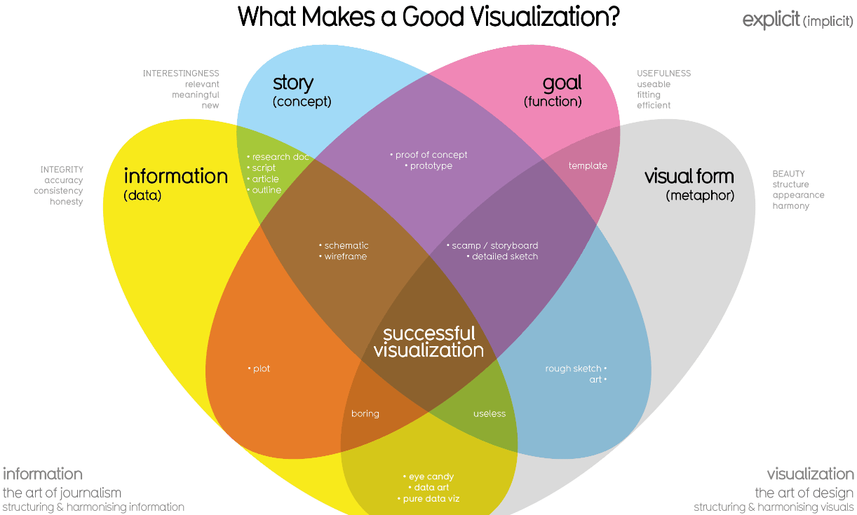

This graphic includes four key elements: **the information or data, the story, the goal and the visual form**. It's arranged in a **four-part Venn diagram**, which tells us that **all four elements are needed for a successful visualization**.

***I - S - G - VF***

So far, you've learned a lot about the **data** used in visualizations. That's important because it's a key building block for your visualization. The story or concept adds meaning to the data and makes it interesting. We'll talk more about the importance of data storytelling later, but for now, just remember that the story and the data combined provide an outline of what you're trying to show. The **goal or function** makes the data both useful and usable, and the visual form creates both beauty and structure. With just two elements, you can create a rough sketch of a visual. This could work if you're at an early stage, but won't give you a complete visualization because you'd be missing other key elements. Even using three elements gets you closer, but you're not quite finished.

For example, if you combine information, goal, and visual form without any story, your visual will probably look fine, but it won't be interesting. **On their own, each element has value, but visualizations only become truly powerful and effective when you combine all four elements in a way that makes sense**. And when you think about all of these elements together, you can create something meaningful for your audience.

At Google I make sure to develop visualizations to tell stories about data that include all four of these elements, and I can tell you that each element is a key to a visualization success. That's why it's so important for you as the analyst to pay close attention to each element as we move forward.

Other people might not know or understand the exact steps you took to come to the conclusions you've made, but that shouldn't stop them from understanding your reasoning. **Basically, an effective data visualization should lead viewers to reach the same conclusion you did, but much more quickly**. Because of the age we live in, we're constantly being shown different ways to view and absorb information. This means that you've already seen lots of visuals you can reference as you design your own visualizations. You have the power to tell convincing stories that could change opinions and shift mindsets. That's pretty cool. But you also have the responsibility to pay attention to the perspectives of others as you create these stories. So it's important to always keep that in mind.

[EFFECTIVE DATA VISUALIZATIONS](https://www.coursera.org/learn/visualize-data/supplement/9xEjx/effective-data-visualizations)

It can be difficult to understand data insights by examining individual data points or a table of information. Often, insights become more obvious when presented in an effective visual format. You can use data visualization (often called “data viz”) techniques to help your audience interpret data in a concise, visual manner.

When creating data visualizations, you must strike a balance between presenting enough information for your audience to understand the meaning of the visualization and not overwhelming them with too much detail. In this reading, you’ll learn tips and techniques for crafting visualizations that are both impactful and effective. You’ll explore:

* Two frameworks for organizing data
* Pre-attentive attributes

## **Frameworks for organizing your thoughts about visualization**

Frameworks help organize your thoughts about data visualization and give you a useful checklist to reference as you plan and evaluate your data visualization. Here are two frameworks that employ slightly different techniques. Both are intended to improve the quality of your visuals.

[The McCandless method](https://www.informationisbeautiful.net/visualizations/what-makes-a-good-data-visualization/)

You learned about the David McCandless method earlier in the course; as a refresher, the McCandless method lists four elements of good data visualization:

1. **Information:** the data with which you’re working
2. **Story:** a clear and compelling narrative or concept
3. **Goal:** a specific objective or function for the visual
4. **Visual form:** an effective use of metaphor or visual expression

The McCandless method provides terminology that isolates the specific elements of a graphic, allowing the person making a visual the ability to evaluate how well those criteria have been met. The aim when crafting a visualization is to incorporate all four elements effectively. Visualizations that fail to incorporate all four elements can be ineffective at communicating insights in various ways. For example, visual form without a goal, story, or data could be a sketch or even art. Data in visual form without a goal or function is just a pretty picture. Data with a goal but no story or visual form can be boring. All four elements need to be present to create an effective visual.

[Kaiser Fung’s Junk Charts trifecta checkup](https://junkcharts.typepad.com/junk_charts/junk-charts-trifecta-checkup-the-definitive-guide.html)

This approach is a set of questions that can help consumers of data visualization critique what they are consuming and determine how effective it is. You can also use these questions to determine if your data visualization is effective:

1. What is the practical question?
2. What does the data say?
3. What does the visual say?

Each of these questions offers an opportunity to investigate a given problem with a slightly different context. A well-designed visual effectively answers all three of those questions at once. Moreover, this framework helps you think about your data viz from the perspective of your audience.

## **Pre-attentive attributes**

In addition to the frameworks mentioned above, several standard building blocks can help you construct your data visualizations. Creating effective visuals means leveraging what is known about how the brain works, and then using specific visual elements to communicate the information effectively. Pre-attentive attributes are the elements of a data visualization that people recognize automatically and without conscious effort. The essential, basic building blocks that make visuals immediately understandable are called marks and channels.

## 

## **Marks**

**Marks** are basic visual objects such as points, lines, and shapes. Every mark can be broken down into four qualities:

1. **Position:** Where is a specific mark in space relative to a scale or to other marks?

For example, if you’re looking at two different trends, position allows you to compare the pattern of one element relative to another.

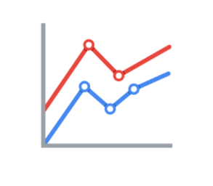

2. **Size:** How big, small, long, or tall is a mark?

The comparison of object sizes can be an easy visual interpretation for humans. This can be very useful for conveying the relationship between categories or data points. However, this also presents a potential problem: The human eye can inadvertently interpret comparisons that aren’t intended to convey meaning. For example, sometimes objects that appear to be the same size when they are not. Controlling the scale of a visual is important even when comparative sizes are not intended to offer information.

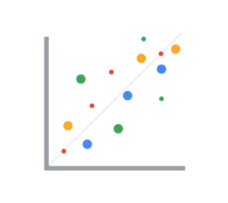

3. **Shape:** Does the shape of a specific object communicate something about it?

Rather than using simple dots or lines, a bit of creativity can enhance how quickly people are able to interpret a visual by using shapes that align with a given application. In the example below, it is immediately obvious that numbers of people are represented because the bars are person-shaped.

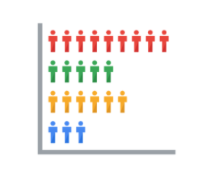

4. **Color:** What color is a mark?

Colors can be used both as a simple differentiator of groupings or as a way to communicate other concepts such as profitable versus unprofitable, or hot versus cold.

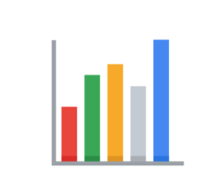

### **Channels**

**Channels** are visual aspects or variables that represent characteristics of the data in a visualization. They are basically specialized marks that have been used to visualize data. It’s important to understand that channels vary in terms of how effective they are at communicating data based on three elements:

1. **Accuracy:** Are the channels helpful in accurately estimating the values being represented?

For example, color is very accurate when communicating categorical differences, such as apples and oranges. But it is much less effective when distinguishing quantitative data, such as 5 from 5.5.

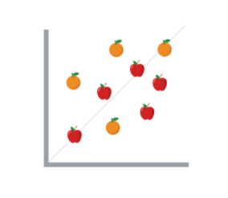

2. **Popout:** How easy is it to distinguish certain values from others?

There are many ways of drawing attention to specific parts of a visual, and lots of them leverage pre-attentive attributes including line length, size, line width, shape, enclosure, hue, and intensity.

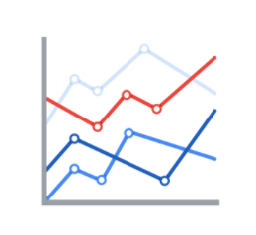

3. **Grouping:** How effective is a channel at communicating groups that exist in the data?

Consider the proximity, similarity, enclosure, connectedness, and continuity of the channel.

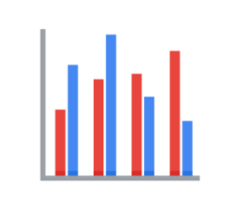

But, remember: The more you emphasize one single thing, the more that counts. Emphasis diminishes with each item you emphasize because the items begin to compete with one another.

## **Key takeaways**

Throughout your career as an analyst, you will use different techniques and types of data visualizations to present data and insights in a concise, impactful manner. This will include organizing your data, selecting the right type of data visualizations, and designing them in such a way that they are easy to understand and highly communicative while avoiding any visuals that are misleading or inaccurate.

Keep in mind that data visualization is an art form, and it takes time to develop these skills. Over your career as a data analyst, you will learn how to design and evaluate data visualizations. Use these tips to think critically about data visualization—both as a creator and as an audience member.

## **Resources**

* [The beauty of data visualization](https://www.ted.com/talks/david_mccandless_the_beauty_of_data_visualization?language=en#t-150183): In this video, David McCandless explains the need for design to not just be beautiful, but for it to be meaningful as well. Data visualization must be able to balance function and form for it to be relevant to your audience.
* [‘The McCandless Method’ of data presentation](https://artscience.blog/home/the-mccandless-method-of-data-presentation): At first glance, this blog appears to be written by a David McCandless fan, and it is. However, it contains very useful information and provides an in-depth look at the 5-step process that McCandless uses to present his data.
* [Information is beautiful](https://informationisbeautiful.net/): Founded by McCandless himself, this site serves as a hub of sample visualizations that make use of the McCandless method. Explore data from the news, science, the economy, and so much more and learn how to make visual decisions based on facts from all kinds of sources.
* [Beautiful news](https://informationisbeautiful.net/beautifulnews/): In this McCandless collection, explore uplifting trends and statistics that are beautifully visualized for your creative enjoyment. A new chart is released every day so be sure to visit often to absorb the amazing things happening all over the world.
* [The Wall Street Journal Guide to Information Graphics: The Dos and Don'ts of Presenting Data, Facts, and Figures](https://www.amazon.com/Street-Journal-Guide-Information-Graphics/dp/0393072959): This is a comprehensive guide to data visualization, including chapters on basic data visualization principles and how to create useful data visualizations even when you find yourself in a tricky situation. This is a useful book to add to your data visualization library, and you can reference it over and over again.

[CONNECT IMAGES WITH DATA](https://www.coursera.org/learn/visualize-data/lecture/h7P9i/connect-images-with-data)

[THE BEAUTY OF VISUALIZING](https://www.coursera.org/learn/visualize-data/supplement/YHHg5/the-beauty-of-visualizing)

[A RECIPE FOR A POWERFUL VISUALIZATION](https://www.coursera.org/learn/visualize-data/lecture/OIKNa/a-recipe-for-a-powerful-visualization)

[CORRELATION AND CAUSATION](https://www.coursera.org/learn/visualize-data/supplement/PPdt5/correlation-and-causation)

[DYNAMIC VISUALIZATIONS](https://www.coursera.org/learn/visualize-data/lecture/423YL/dynamic-visualizations)

[THE WONDERFUL WORLD OF VISUALIZATIONS](https://www.coursera.org/learn/visualize-data/supplement/j9Wdl/the-wonderful-world-of-visualizations)

[DATA GROWS ON DECISION TREES](https://www.coursera.org/learn/visualize-data/supplement/XvN2U/data-grows-on-decision-trees)

[SELF-REFLECTION: CHOOSE YOUR VISUALIZATION TYPE](https://www.coursera.org/learn/visualize-data/quiz/L1Tds/self-reflection-choose-your-visualization-type)

[TEST YOUR KNOWLEDGE ON DATA VISUALIZATIONS](https://www.coursera.org/learn/visualize-data/quiz/CbiAX/test-your-knowledge-on-data-visualizations)

DESIGN DATA VISUALIZATIONS

[ELEMENTS OF ART](https://www.coursera.org/learn/visualize-data/lecture/ja0Ab/elements-of-art)

[PRINCIPLES OF DESIGN](https://www.coursera.org/learn/visualize-data/supplement/Ijxn6/principles-of-design)

[DATA VISUALIZATION IMPACT](https://www.coursera.org/learn/visualize-data/lecture/pzUSm/data-visualization-impact)

[DATA IS BEAUTIFUL](https://www.coursera.org/learn/visualize-data/supplement/Z2Ox1/data-is-beautiful)

[DESIGN THINKING AND VISUALIZATIONS](https://www.coursera.org/learn/visualize-data/lecture/9v3UG/design-thinking-and-visualizations)

[[OPTIONAL] DESIGN THINKING FOR VISUALIZATION IMPROVEMENT](https://www.coursera.org/learn/visualize-data/supplement/ihlqt/optional-design-thinking-for-visualization-improvement)

[IDENTIFY DATA VISUALIZATIONS IN YOUR LIFE](https://www.coursera.org/learn/visualize-data/discussionPrompt/iAEJS/identify-data-visualizations-in-your-life)

[TEST YOUR KNOWLEDGE ON DESIGNING DATA VISUALIZATIONS](https://www.coursera.org/learn/visualize-data/quiz/8nFLr/test-your-knowledge-on-designing-data-visualizations)

VISUALIZATION CONSIDERATIONS

[PRO TIPS FOR HIGHLIGHTING KEY INFORMATION](https://www.coursera.org/learn/visualize-data/supplement/ewNyk/pro-tips-for-highlighting-key-information)

[ACCESSIBLE VISUALIZATIONS](https://www.coursera.org/learn/visualize-data/lecture/yVjKD/accessible-visualizations)

[ANDREW: MAKING DATA ACCESSIBLE](https://www.coursera.org/learn/visualize-data/lecture/nGSKz/andrew-making-data-accessible)

[DESIGN A CHART IN 60 MINUTES](https://www.coursera.org/learn/visualize-data/supplement/IcuWb/design-a-chart-in-60-minutes)

[HANDS-ON ACTIVITY: CREATE YOUR OWN VISUALIZATION](https://www.coursera.org/learn/visualize-data/quiz/nidlM/hands-on-activity-create-your-own-visualization)

[TEST YOUR KNOWLEDGE ON EXPLORING DATA VISUALIZATIONS](https://www.coursera.org/learn/visualize-data/quiz/wDQkr/test-your-knowledge-on-exploring-data-visualizations)

M1 CHALLENGE

### [GLOSSARY TERMS FROM MODULE 1](https://www.coursera.org/learn/visualize-data/supplement/uajvO/glossary-terms-from-module-1)